5 Working with POST Requests



This section will guide you to understand:

* How to POST a Request on Postman
* Response of POST Request

**Development Environment:**

* Postman Tool
* URL

This guide has four subsections, namely:

2.5.1 Creating a POST Request

2.5.2 Writing the body of Request

2.5.3 Checking response

2.5.4 Pushing the code to your github repositories

**Step 2.5.1:** Creating a POST Request

* Click a new tab to create a new request

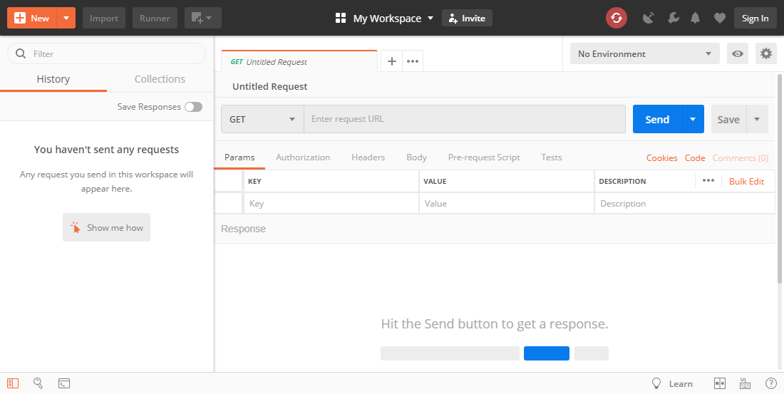

* Set your HTTP request to POST
* Input the same link in request url:<https://reqres.in/api/users>
* Switch to body tab

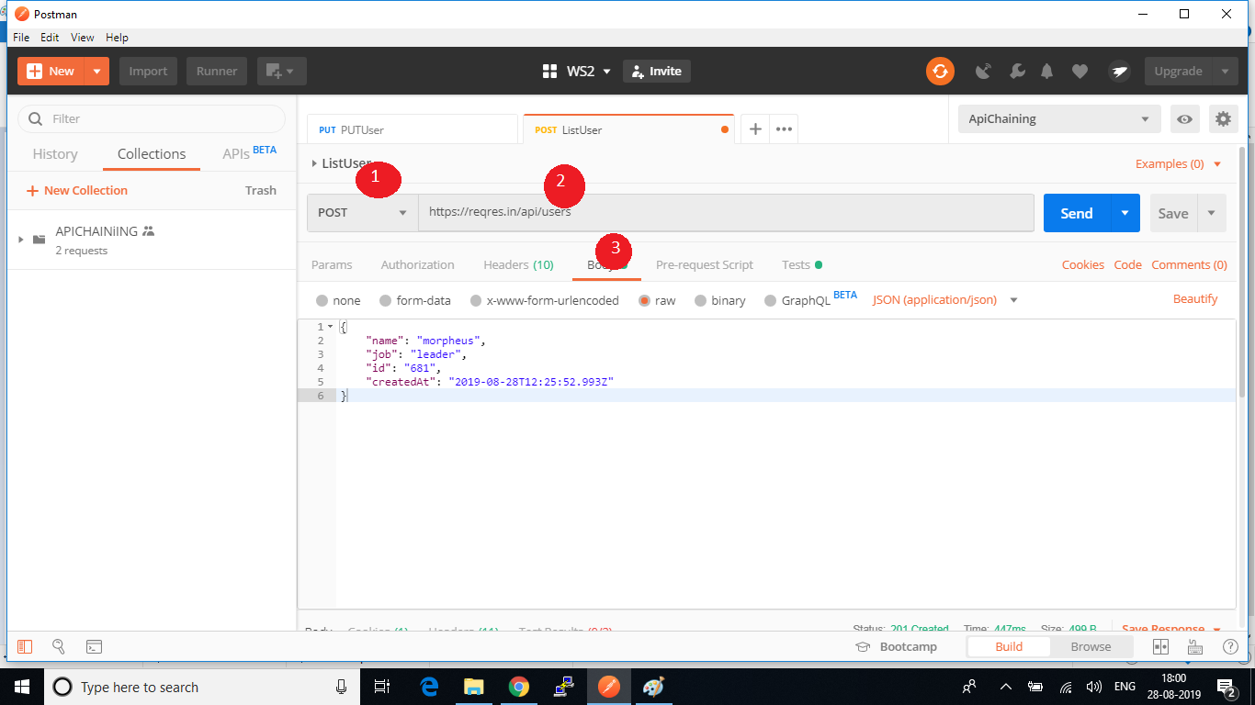

**Step 2.5.2:** Writing the body of Request

* Click **raw**
* Click **JSON**
* In the code editor, add the following data to the file:

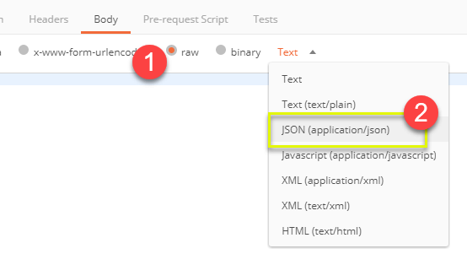

* Copy and paste just one user result from the previous get request like below. Ensure that the code has been copied correctly with paired curly braces and brackets. Change id to 11 and name it to any desired name. You can also change other details like the address.

[ {

"name": "morpheus",

"job": "leader",

"id": "463",

"createdAt": "2019-08-28T10:51:59.088Z"

}

]

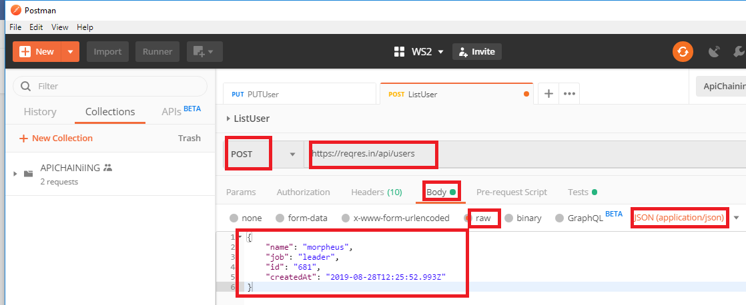

**Step 2.5.3:** Checking response

* Click Send
* Status: **201 Created** should be displayed
* Request body data is displayed in the response body

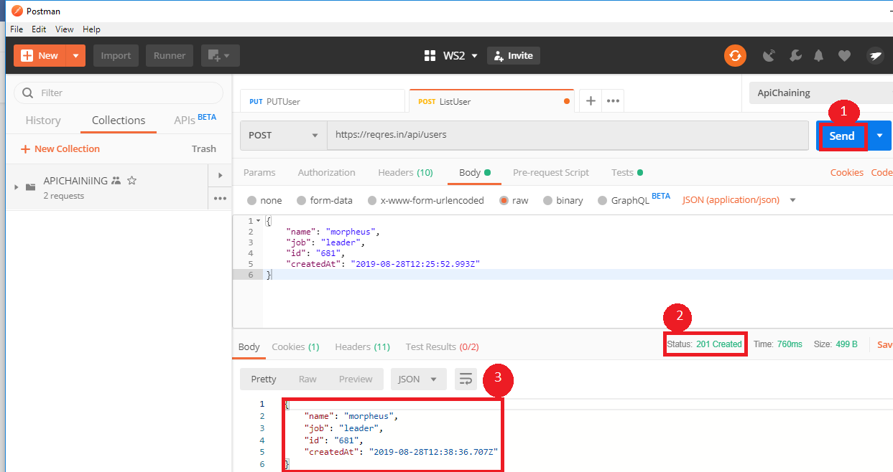

**Step 2.5.4:** Pushing the code to your github repositories

Open your command prompt and navigate to the folder where you have created your files

cd <folder path>

Initialize your repository using the following command:

git init

Add all the files to your git repository using the following command:

git add . 

Commit the changes using the following command:

git commit . -m “Changes have been committed.”

Push the files to the folder you initially created using the following command:

git push -u origin master